**1. INTRODUCTION**

The project entitled as “College Bus Management System” is mainly developed to the transport details of college using php as front end and SQL as back end.

The purpose of these development included in this project is to replace the original management system with a computerized system. This system describes the whole details of bus, driver, student, staff management and fee details based on the student destination place. In the bus details the total number of bus, services and spare parts are described.

Bus maintenance is necessary to know the condition of the bus. Route details are specified separately. Student details are registered at the management to know student’s travel in the college bus is maintained. Only registered students are allowed to travel in the college bus. Every student must know starting time of the college bus from source place. Trip management is maintained by the administrator to know how many buses go for particular places and total number of buses takes off from college by day to day process. Fee payment is maintained by the office administrator. Student and staff attendance in college bus is handled by one of the student in same bus. At last the report generate for the total process. The Bus Management System can be using a username and password. It is accessible either by an administrator or receptionist. Only they can add data into the database.

**1.1GOAL OF PROJECT**

The main objective of this system is to reduce the consumption of time during maintaining the records of college Transport management. Separate divisions are provide to maintain the records of Student, faculty, Roots, diversion, etc.

Our software will overcome all these Safe, efficient, reliable, and sustainable movement of persons and goods over time and space.

**1.2 SCOPE OF THE PROJECT**

* Adding new data to database.
* Saving data in database.
* Retrieving data from the database.
* Search existing data from the database.
* Immediate printing of receipt and bus passes.

**2.LITERATURE SURVEY**

Transport is one of the important infrastructures and mean of concern for the growth of any country.

The problems that arise due to unconditional transportation are uncertainity of waiting time due to traffic jam and any other issue live abnormal conditioning. Now a day the safety and privacy becomes main concern for private and public vehicles while travelling.

**2.1 EXISTING SYSTEM**

Today all the work at the time of taking transport services of the students is done manually by ink and paper, which is very slow and consuming much efforts and time.

Since the numbers of students is growing, and management has to handle records of all the students, it is facing a little bit problems in maintaining the records of students and other details.

It is required to Design of a Computerized College Transport Management System, to speed up and make it easy to use system.

**2.2 PROPOSED SYSTEM**

In our proposed system we have the provision for adding the details of the students.

Another advantage of the system is that it is very easy to edit the details of the student and delete a student when it found unnecessary. Here is facility of find root, direction, individual profile facility is also provided. Online updating and changes is possible.

By developing the system, we can attain the following facilities.

* Easy to handle and feasible.
* Easy to operate.
* Cost reduction.
* Fast and convenient.

**2.2 FEASIBILITY STUDY**

In other words the objective of the present college Transport management software are:

* Simple database is maintained.
* Easy operation for the operator of the System.
* Faster execution & maintaining the records.
* User interface are user friendly and attractive, it takes very less time for the operator to get use-to with the system.

**2.3 TOOLS AND TECHNOLOGIES USED**

**2.3.1. HTML**

• HTML is short for HyperText Markup Language.

• Hypertext is simply a piece of text that works as a link.

• Webpages are written in HTML - a simple scripting language.

• Markup Language is a way of writing layout information within documents.

• Basically an HTML document is a plain text file that contains text and nothing else.

• When a browser opens an HTML file, the browser will look for HTML codes in the text and use them to change the layout, insert images, or create links to other pages.

• Since HTML documents are just text files they can be written in even the simplest text editor.

**2.3.2. CSS**

* Cascading Style Sheets, fondly referred to as CSS, is a simple design language intended to simplify the process of making web pages presentable.
* CSS handles the look and feel part of a web page. Using CSS, you can control thecolor of the text, the style of fonts, the spacing between paragraphs, how columns are sizedand laid out, what background images or colors are used, as well as a variety of othereffects.
* CSS is easy to learn and understand but it provides powerful control over thepresentation of an HTML document. Most commonly, CSS is combined with the markuplanguages HTML or XHTML.

**ADVANTAGES OF CSS:**

* **CSS Saves Time**- You can write CSS once and then reuse same sheet in multiple HTML pages. You can define a style for each HTML element and apply it to as many Web pages as you want.
* **Pages load faster**. - If you are using CSS, you do not need to write HTML tag attributes every time. Just write one CSS rule of a tag and apply to all the occurrences of that tag. So less code means faster download times.
* **Easy maintenance** - To make a global change, simply change the style, and all elements in all the web pages will be updated automatically.
* **Superior styles to HTML** - CSS has a much wider array of attributes than HTML so you can give far better look to your HTML page in comparison of HTML attributes.
* **Multiple Device Compatibility** - Style sheets allow content to be optimized for more than one type of device. By using the same HTML document, different versions of a website can be presented for handheld devices such as PDAs and cell phones or for printing.
* **Global web standards** - Now HTML attributes are being deprecated and it is being recommended to use CSS. So its a good idea to start using CSS in all the HTML pages to make them compatible to future browse.

**2.3.3.JAVA SCRIPT**

JavaScript is not a programming language in strict sense. Instead, it is a scripting language because it uses the browser to do the dirty work. If you command an image to be replaced by another one, JavaScript tells the browser to go do it. Because the browser actually does the work, you only need to pull some strings by writing some relatively easy lines of code. That’s what makes JavaScript an easy language to start with. But don’t be fooled by some beginner’s luck: JavaScript can be pretty difficult, too. First of all, despite its simple appearance it is a full fledged programming language, it is possible to write quite complex programs in JavaScript. This is rarely necessary when dealing with web pages, but it is possible. This means that there are some complex programming structures that you’ll only understand after protracted studies.

Secondly, and more importantly, there are the browser differences. Though modern web browsers all support JavaScript, there is no sacred law that says they should support exactly the same JavaScript. A large part of this site is devoted to exploring and explaining these browser differences and finding ways to cope with them. So basic JavaScript is easy to learn, but when you start writing advanced scripts browser differences (and occasionally syntactic problems) will creep up.

**2.3.4.MYSQL**

A database is a separate application that stores a collection of data. Each database has one or more distinct APIs for creating, accessing, managing, searching and replicating the data it holds. Other kinds of data stores can be used, such as files on the file system or large hash tables in memory but data fetching and writing would not be so fast and easy with those types of systems. So nowadays, we use relational database management systems (RDBMS) to store and manage huge volume of data. This is called relational database because all the data is stored into different tables and relations are established using primary keys or other keys known as foreign keys.

**2.4 HARDWARE AND SOFTWARE REQUIREMENTS**

**HARDWARE REQUIREMENTS:**

* Hardware - Pentium
* Speed - 1.1GHz
* RAM - 1GB
* Hard Disk - 20 GB
* Floppy Drive - 1.44 MB
* Key Board - Standard Windows Keyboard
* Mouse - Two or Three Button Mouse

**SOFTWARE REQUIREMENTS:**

* Operating System - Windows
* Technology - PHP
* Web Technologies - HTML, JAVASCRIPT, CSS
* IDE - Notepad++
* Web Server - Wamp2.2e
* Database **-** My SQL

**3. SOFTWARE REQUIREMENTS SPECIFICATION**

**3.1 FUNCTIONAL REQUIREMENTS**

The main modules involved in this system are:

* Login
* Forms
* Reports
* Announcement

**3.1.1 Login**

* Login module is used to check whether the user is an authorized person to use the system or not. For this the user should give the correct user name and password.
* The different types of users are

Admin

Account

Student

Employee/Faculty

**3.1.2 Forms**

This module consists of the following sub modules

* Student/Faculty Registration Form
* Student/Faculty ID Form
* Student/Faculty Detail Form
* Account Detail Form

**3.1.3 Reports**

All the above mentioned data are stored in the back end and can be retrieved as reports with filtering options.

The Following are the reports can be taken from this system

* Student Report
* Faculty Report
* Account Detail Report

**3.2 NONFUNCTIONAL REQUIREMENTS**

* **Efficiency Requirement**
  + - When college transportation system implemented students/staffs are use this system in efficient manner.
* **Reliability Requirement**
  + - The system should provide a reliable environment to both students and staffs.
* **Usability Requirement**
  + - The web application is designed for user friendly environment and ease of use.
* **Implementation Requirements**
  + - Implementation of the system using html and css in front end with Mysql as backend and it will be used for database connectivity.

**4. SYSTEM DESIGN**

**4.1 DATA FLOW DIAGRAM**

Data flow diagram is a graphical tool used to describe and analyze the movement of data through a system, where the system is modeled using the data transformation which takes place as it is processed. Data flow diagram is the central tool and the basis from which other components are developed. The transformation of data from input to output through process may be described logically and independently of the physical components like computers, file cabinet, disk units etc associated with the system.

A data flow diagram might represent data flow between individual statements or block of statements in a routine, data flow between sequential routines, data flow between concurrent processes, or data flow in a distributed computing system.

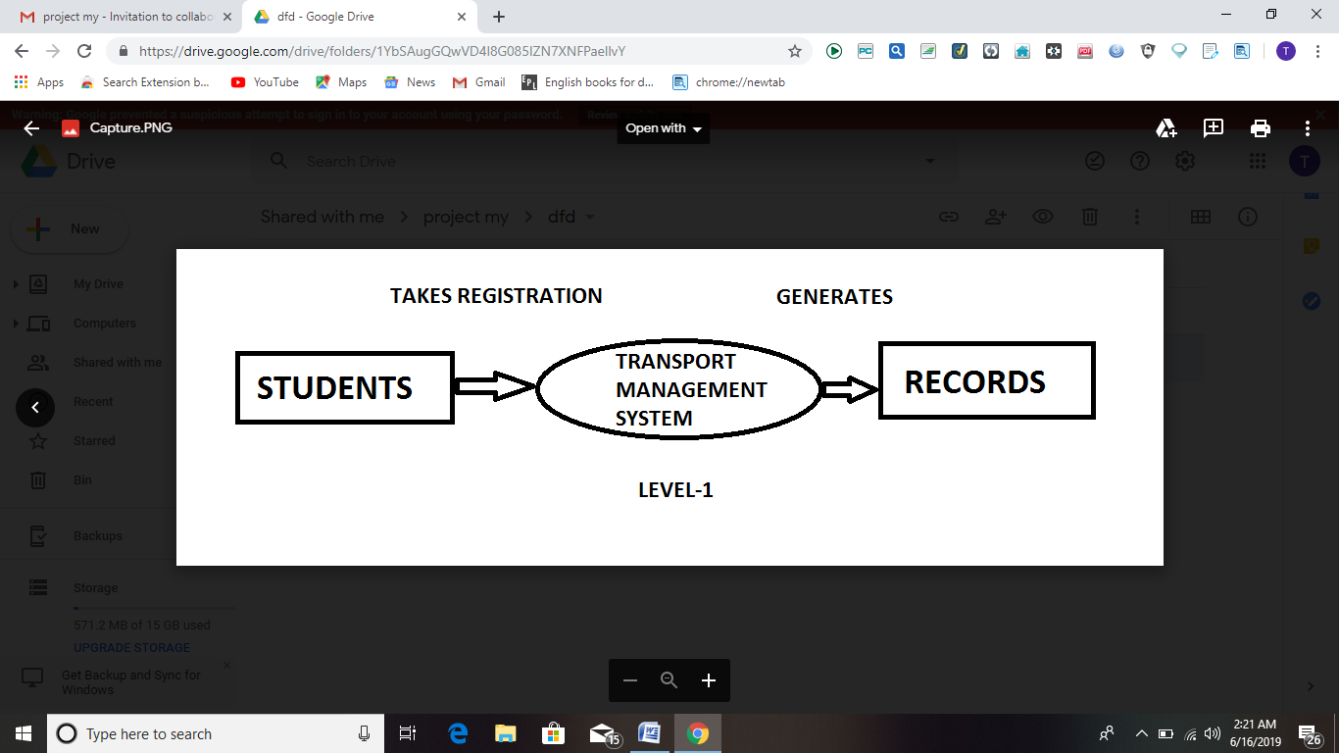

Figure 4.1 Data Flow Diagram Level 1

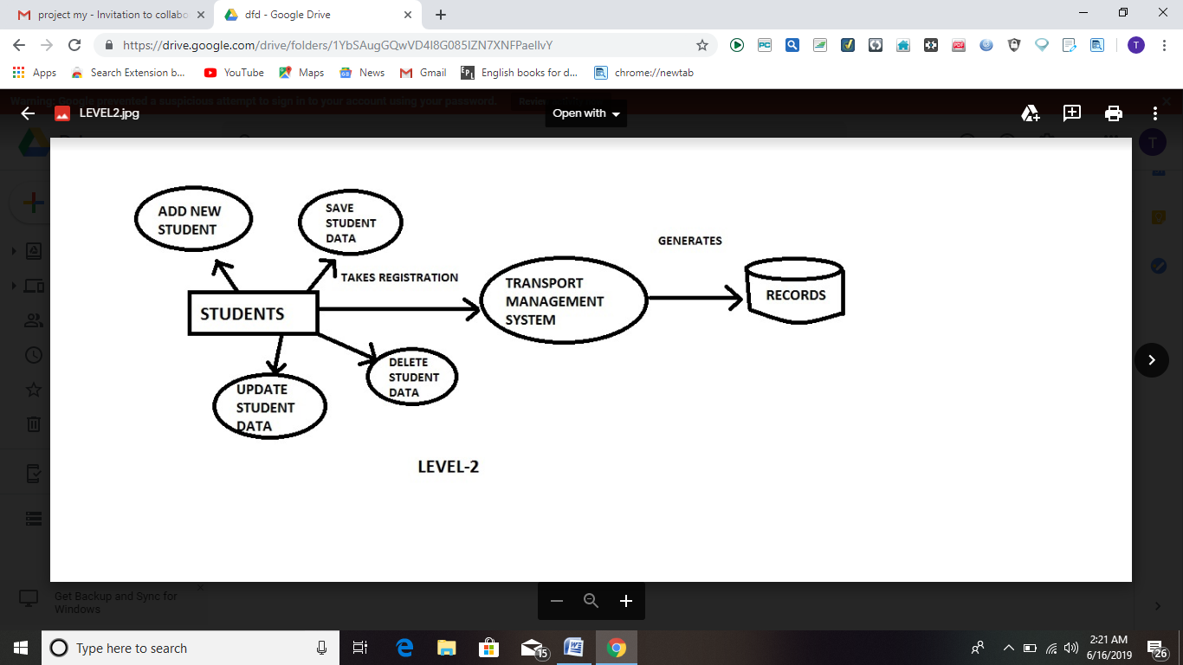

Figure 4.2 Data Flow Diagram Level 2

**4.2USE CASE DIAGRAM**

**Admin**

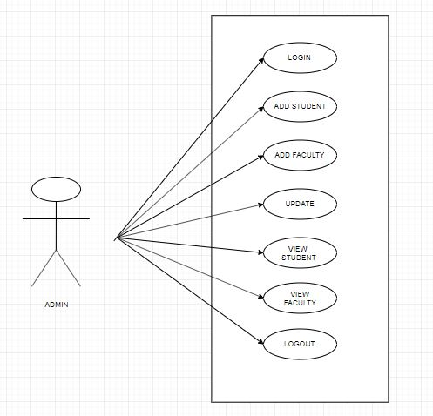

**5.IMPLMENTATION**

**5.1 CODE:**

<html>

<h2><center><u>FACULTY</u></center><h2>

<body background="a.jpg">

</body>

<?php

include("connection.php");

error_reporting(0);

$query = "SELECT * FROM student WHERE choose LIKE 'FACULTY'";

$data = mysqli_query($conn,$query);

$total = mysqli_num_rows($data);

if($total != 0)

{

?>

<table border="2" align="center">

<tr>

<th>NAME</th>

<th>FATHER NAME</th>

<th>DOB</th>

<th>PICKUP</th>

<th>DROP</th>

<th>AMOUNT</th>

</tr>

<?php

while($result = mysqli_fetch_assoc($data))

{

echo "<tr>

<td>".$result['name']."</td>

<td>".$result['fathername']."</td>

<td>".$result['dob']."</td>

<td>".$result['pickup']."</td>

<td>".$result['drop']."</td>

<td>".$result['amount']."</td>

</tr>";

}

}

else

{

echo "";

}

?>

</table>

<a href="dashboard.php">BACK</a>

</html>

**5.2 SNAPSHOTS**

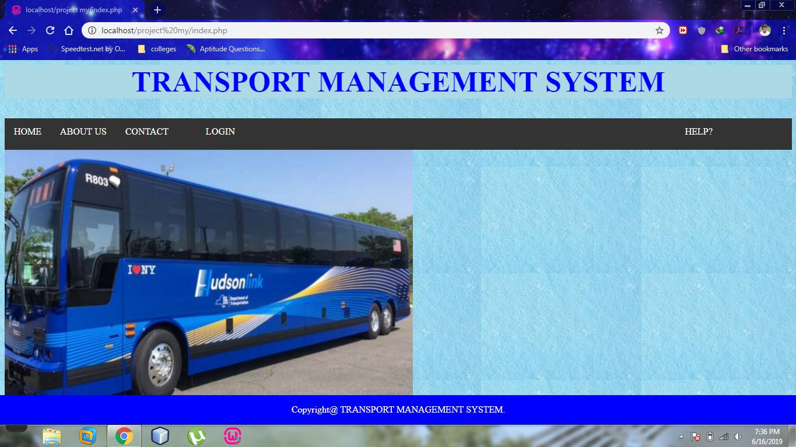Figure 5.2.1 Home Page

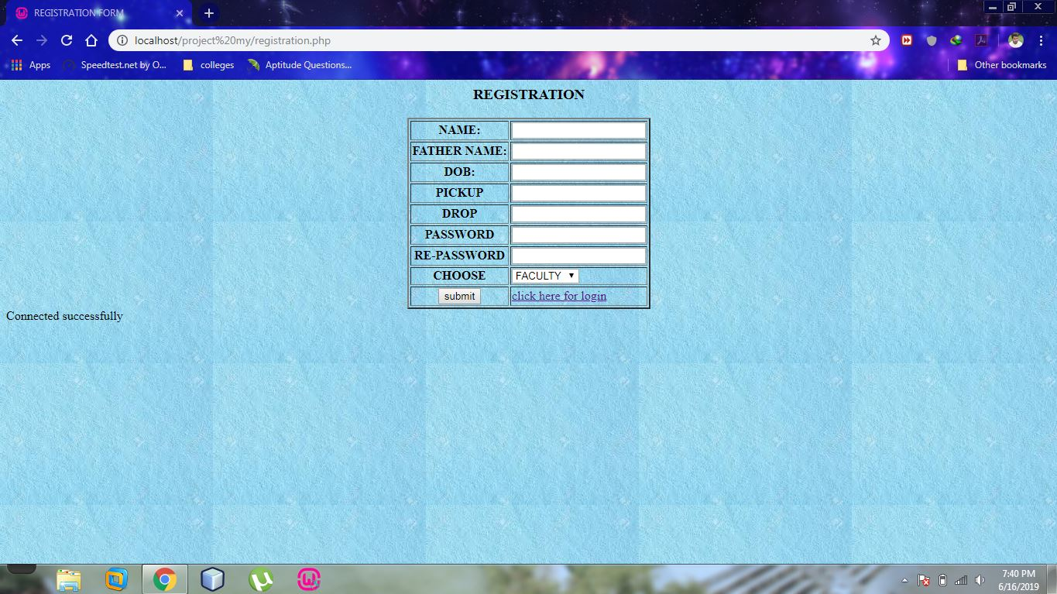

Figure 5.2.2 Registartion.php Page

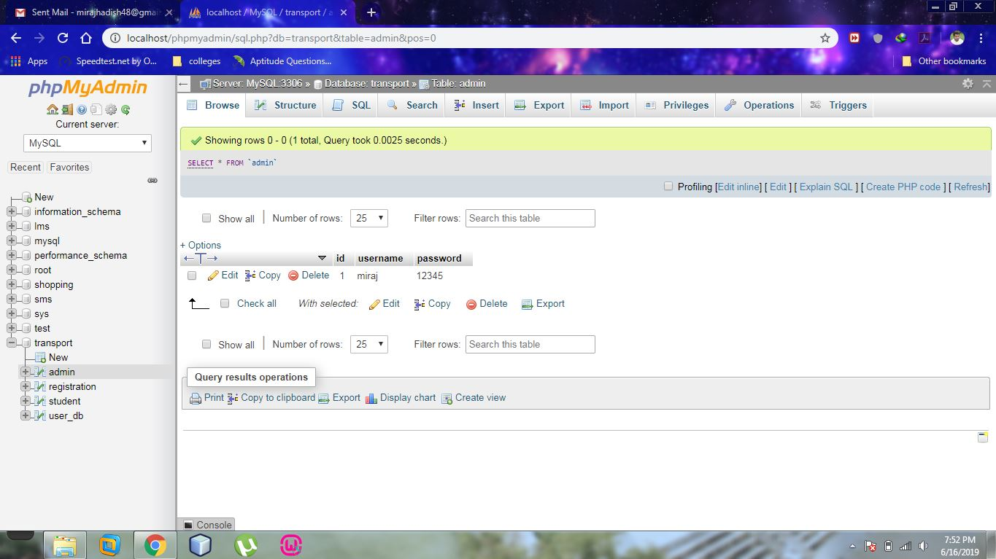

Figure 5.2.3 Admin/sql.php Page

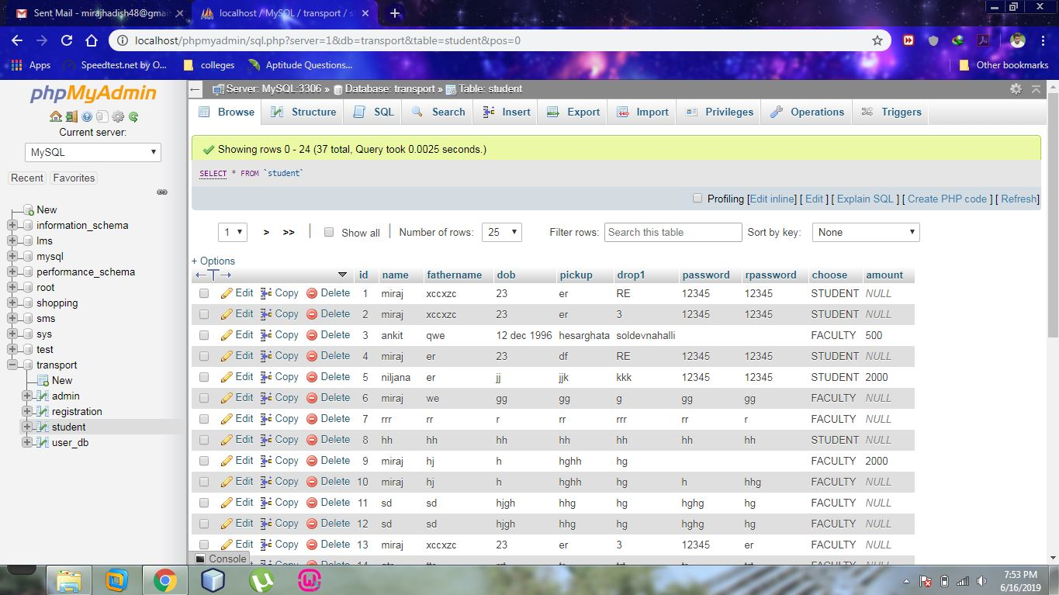

Figure 5.2.4 Student form Page

**6.SOFTWARE TESTING**

**6.1.INTRODUCTION**

Software testing is an investigation conducted to provide stakeholders with information about the quality of the software product or service under test. Software testing can also provide an objective, independent view of the software to allow the business to appreciate and understand the risks of software implementation. Test techniques include the process of executing a program or application with the intent of finding software bugs (errors or other defects), and verifying that the software product is fit for use.

**6.2.PURPOSE**

Software testing involves the execution of a software component or system component to evaluate one or more properties of interest. In general, these properties indicate the extent to which the component or system under test:

• meets the requirements that guided its design and development,

• responds correctly to all kinds of inputs,

• performs its functions within an acceptable time,

•it is sufficiently usable,

• can be installed and run in its intended environments, and

• achieves the general result its stakeholders desire.

**6.3.TESTING METHODS**

**• Unit Testing**

Testing of an individual software component or module is termed as Unit Testing. It is typically done by the programmer and not by testers, as it requires a detailed knowledge of the internal program design and code. It may also require developing test driver modules or test harnesses.

**• System Testing**

Under System Testing technique, the entire system is tested as per the requirements. It is a Black-box type testing that is based on overall requirement specifications and covers all the combined parts of a system

•**Integration Testing**

Integration testing is a level of software testing where individual units are combined and tested as a group. the purpose of this level of testing is to expose faults in the interaction between integrated units. test drivers and test stubs are used to assist in integration testing.

•**Acceptance Testing**

Acceptance testing is a level of software testing where a system is tested for acceptability. the purpose of this test is to evaluate the system’s compliance with the business requirements and assess whether it is acceptable for delivery.

•**White-box testing**

White-box testing (also known as clear box testing, glass box testing, transparent box testing, and structural testing) verifies the internal structures or workings of a program, as opposed to the functionality exposed to the end-user. In white-box testing, an internal perspective of the system (the source code), as well as programming skills, are used to design test cases. The tester chooses inputs to exercise paths through the code and determine the appropriate outputs. This is analogous to testing nodes in a circuit, e.g., in-circuit testing (ICT).

•**Black-box testing**

Black-box testing (also known as functional testing) treats the software as a "black box," examining functionality without any knowledge of internal implementation, without seeing the source code. The testers are only aware of what the software is supposed to do, not how it does it.

**7.CONCLUSION**

**College bus management system**is generally based on regular operation for college bus details can be stored in systematic and maintained in name wise.

Bus information system is software which will be Inform about the transport facility in college and Institute. Bus information will provide the detail about the bus student and manage the contents about the system. The data can be retrieved easily. The interface is very user-friendly. The data are well protected for personal use and makes the data processing very fast and find the bus student information quickly according to class and name both details.

**8.FUTURE ENHANCEMENT**

In future development ,can possible to design three section: GEO Tracking, Scheduling and fair query and security module.

We can also consider adding more features and improvements such as a notification messages, calculating the remaining time, and a notification when all are on-board.

There is a possibility to modify our system by adding a 3D map at least for the famous places in the route for example Acharya institutes when the route is Acharya location it can appear in 3D.

**9. BIBLIOGRAPHY**

[www.w3](http://WWW.W3) schools.com

www.slideshare.com

www.scribd.com